UNIT 4 ASSIGNMENT 2

Programming

Oliver Collins-Cope

2022

Contents

Introduction 2

Scope of Project – Design 2

Mobile requirements 2

Device capabilities 2

Input required 2

Output required 3

User needs 3

# Introduction

# Scope of Project – Design

The project is to create a program for temporary traffic lights that can be operated using a mobile device. It is being created due to the roadwork occurring and it will help to allow traffic to flow functionally without halting day to day life. It has been approved by the relevant organisation “Highway-RUTC Road Services” and the project will be completed through numerous different phases which will be elaborated on further, such as planning and implementation phases. The product produced will be a functioning program which will be able to change traffic lights using a mobile, and will follow the predetermined eight set instruction sequence that lasts forty-four seconds. It will be delivered by the 20th of May and is estimated to cost a grand total of £0 through the use of ~~slave~~ student labour.

To be included in the program includes the correct operational sequences for both Set A and Set B of the traffic lights. Furthermore, there will be an option to override the operational sequence in order to set both traffic lights to red in case of an incident/accident. Following this, the user will be able to safely restart the traffic light operational sequence after overriding the program and it will continue to function smoothly. All of this will be achieved through a mobile app that will be developed around the program I will create.

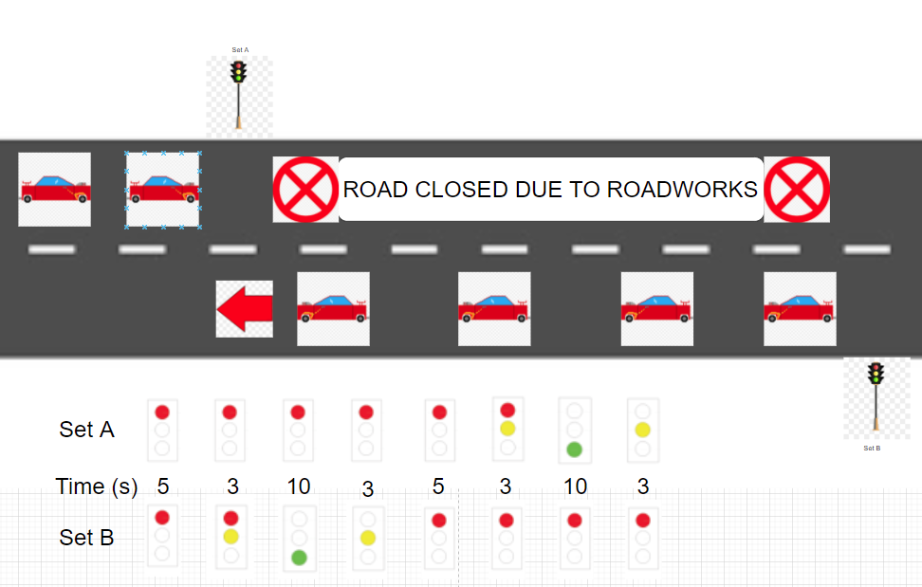

## Mobile requirements

There are four components to consider for the mobile application to consider when designing the mobile application. These are:

* Device capabilities
* Input required
* Output required
* User needs

### Device capabilities

The device capabilities refer to things such as GPS, or an accelerometer. For this situation/program, it is important that the devices that use the app we create have touch screen capabilities in order for the user to interact with the buttons that will be present in the application, whether it is to activate the program or to activate the emergency stop.

### Input required

Similar to the device capabilities that we require for this application and program, “Input required” refers to what input the program will seek from the user, such as voice input, or a timed event. For our program, we will be using a combination of touch screen and timed events.

We will be using touch screen in order to begin the program and activate the emergency stop using the mobile device on the application, and we will be using timed events to ensure that the operational sequences on the traffic lights eight different options runs smoothly and in time to prevent issues arriving from cars colliding.

### Output required

The output required asks the program what the output of the input will be. As mentioned above, this will be the traffic lights working in the order they are established to be working in, going through the eight different sequences, along with the emergency stop option.

This is important as this output component will be what allows the program to operate functionally and dictate the response from what the user inputs.

### User needs

Finally, there are also the user needs to consider, such as whether the user needs accessibility options, or any kind of location services. In this situation, some examples of possible user needs may be a password protected system, so only authorised users are able to affect the traffic lights, and accessibility options in-case the user operating the application might have different disabilities, such as blindness or epilepsy. We can achieve these different user needs by ensuring the program is able to be accessed by third party voice screen readers and applications such as “VoiceOver” by Apple. We can cater to epilepsy users needs by ensuring that the application/program does not contain any potentially triggering content, such as flashing lights.

These are important to consider as making an application as accessible as possible to different users is crucial as a developer in order to allow for as many users as possible to be able to use the application and not be restricted by their disabilities. Furthermore, it is also good practice to ensure that disabled users are able to access and fully use the produced application just the same as abled users.

## Pseudocode for Program

Input Driver Age

If Driver Age is greater than 16

Then they are allowed to drive

Else

They are not allowed to drive

Is there an accident?

Input Yes/No

If Yes

Then Emergency Stop

Else

Continue running traffic lights

Input Touch screen

If button program is pressed

Traffic lights Set A Off/Red (5)

Traffic lights Set B Off/Red (5)

Traffic lights Set A Off/Red (3)

Traffic lights Set B Half/Red&Yellow (3)

Traffic lights Set A Off/Red (10)

Traffic lights Set B On/Green (10)

ETC

Else

Program does not run and traffic lights stay off

Input Age

If Age is greater than 16

Return Yes

Else

Return No

Module Module1

Sub Main()

Dim Age as Integer = Nothing

Console.WriteLine(“What is your age?”)

Age = Console.ReadLine()

If Age >= “16” Then

Console.WriteLine(“You are old enough to drive”)

Else

Console.WriteLine(“You are not old enough to drive”)

End If

Console.ReadLine()

End Sub

End Module

## Software solutions design

There are several things to include when discussing the software design and viable solutions. To begin with, I will discuss different problems that must be resolved before planning out the software and programming.

### To resolve

These include:

* Intended users
* Summary of the program and solutions
* Constraints
* Benefits
* Interactivity
* Complexity

#### Intended users

The intended users of this application and software will be members of the company Highway RUTC Road Services, which are likely to be slightly older people who might not be as technologically literate, and therefore our software should be as simple as possible to minimise chances of confusion.

#### Summary of the program and solutions

The program will include a diagram of the two sets of traffic lights, and these traffic lights will change colour depending on the timing of the predefined operational sequence. Due to the fact that the brief states that the actual timing of the traffic lights will be different, it will be important to include the option to easily be able to change the timing of each step of the correct operational sequence.

One way I will be able to achieve this is through setting up an internal timer with the code, and when the timer reaches a certain value, it will change the colour of the traffic lights and therefore run through the correct operational sequences.

#### Constraints

Some constraints that may be encountered along the way with the development of this program could be that setting up the internal timer and making sure it functions the way it is required will be much harder than initially predicted and therefore there may be bugs or I will have to change the way I decide what time to change the code.

Another constraint I may come across would be I am able to turn this into a mobile application and have it run for the user; However, I believe that I have resolved this issue already through deciding how I am going to make my software, which I will discuss in the section below.

#### Benefits

I will be using the game development software “Unity” in order to make my software application. I believe this is a benefit because it allows for builds in mobile which means I do not have to worry about making my program function on mobile. In addition to this, I will be able to make different menus for the user and present customisable options through the use of “scenes” and “game objects” which interact with each other.

#### Interactivity

The interactivity of my application will be limited to buttons that the user can press in order to achieve the desired results. I am limiting the interactivity of my application in order to reduce confusion and limit user error. This will result in less errors occurring and less bugs developing and therefore the application will continue to work for longer without the need for updates or hotfixes.

#### Complexity

I do not believe that my application will be particularly complex, and I will do all I can to ensure that the UI of my application and the navigation of my application will be simple in order to reduce complexity and confusion.

### Purpose and requirements

In this section I will clearly outline the purpose of my application and the requirements of the user in further detail, while including how I will meet these requirements and my justification for doing in that way.

#### Purpose

The purpose of this software and mobile application will be to create a software solution that can operate a traffic light software system using predetermined operational sequences.

#### Requirements

The requirements of this software solution include following the correct operational sequence, which I will achieve through using a timer, and I will be doing it in this way as it will allow me to keep track of the timing within the code and allow it to be independent. To be able to safely override the operational sequence and restart it in the case of an emergency, which I will achieve by including a button which stops the code from executing and sets the lights to red. Finally, to develop a mobile app for this which can achieve this, which I will do using Unity because it has build options for mobile.

### Features of the software design

The features of the software design will cover:

* Main tasks, inputs, and outputs
* Illustrations
* Algorithms and pseudocode
* Data Structures(?)
* Data Storage(?)
* Control structures
* Data validation
* Error handling and reporting